FORMATTING YOUR FULL PAPER
A TEMPLATE FOR THE CNS ICNF 2026 SUBMISSIONS
Initials. Last NameAuthor1¹, Initials. Last NameAuthor2² and Initials. Last NameAuthor3¹
¹ McMaster University, Hamilton, Ontario, Canada
² Canadian Nuclear Laboratories, Chalk River, Ontario, Canada
Email1@address.ca, email2@address.ca, email3@address.ca
Abstract
The abstract at the start of the paper is to be no more than 150 words. The required full paper is to be submitted in Microsoft Word. Papers for the 16th CNS International Conference on Nuclear Fuel (CNS ICNF 2026) should be submitted directly to:
https://www.xcdsystem.com/cns/abstract/index.cfm?ID=HiSAy13

Introduction
This document provides the template for authors to format their papers to a common standard used for the CNS Conference.
To ensure a uniform presentation and standard of content in the papers submitted to CNS ICNF 2026, the page limit of full papers is 12 letter-size (8.5”x11”) pages including tables, figures and references. The page limit will help the authors to concentrate their discussions and materials. The preferred electronic size of each paper is less than 1 MB.
The text margins are to be set so that the text body is within the dimensions of 1-inch margins top, bottom, left and right.

Body text formatting
The body text of the paper contains headings, subheadings, pictures, diagrams, tables, figures, formulae and other relevant information. Section headings should be in bolded 12-point Times New Roman font. A number and a dot should be inserted for each heading, in increasing order to the end of the paper. The first letter of the heading should be upper case, and the rest of the heading is lower case unless the word requires upper case (e.g., Super-Critical Water-cooled Reactors). Include a tab space of 0.5 inch from the left margin to the heading itself. Leave 2 blank lines (24 pt space) between the last paragraph and the heading title line – this template has been adjusted so that the paragraph and heading spacing is correct. Paragraphs in the body text are separated by one blank line (a 12 pt space at the end of the paragraph is used in this template). You are encouraged to use page breaks to force heading titles to appear on the same page as the text of that section.
Body text should be in normal 12-point Times New Roman font. If you want to emphasise certain words in the text, you can highlight those words by using bolded, italicized, or underlined font, or by changing the font type and size, provided these changes are confined to drawing the attention of the readers. The overall paper must be in normal 12-point Times New Roman font.
Figures (diagrams and photographs) and tables can be included anywhere in the text other than the title, author list or affiliation list. Figures should be numbered consecutively throughout the paper from Figure 1 onwards. Tables should be numbered consecutively throughout the paper from Table 1 onwards. All figures, tables and their captions are to be centred. The figure caption should appear below the respective figure and the table caption should appear above the respective table. Ensure figures and tables are within the printable area of the page. The conversion of your Microsoft Word file to a pdf file can result in omission of images if they are not within the printable area of the page.

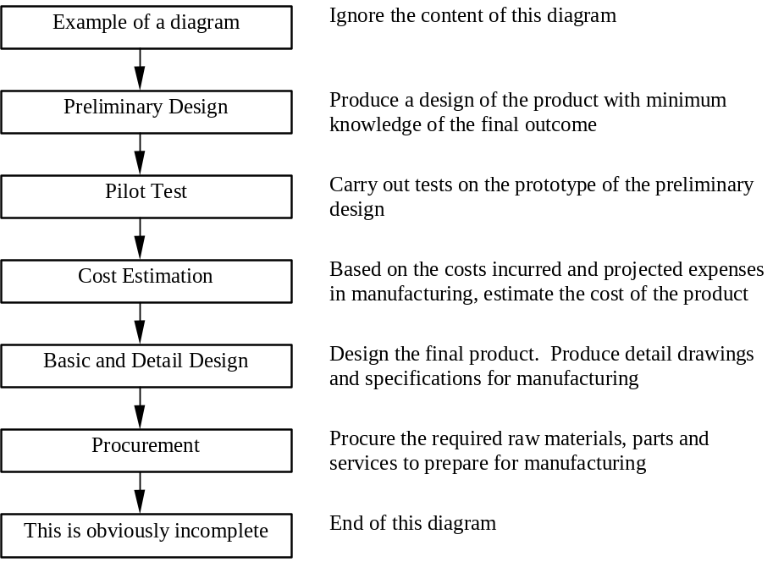

Figure 1 Example of a diagram.

There is no restriction on the size of a diagram but, as a general rule, a diagram should not extend beyond the margin of the letter paper in any direction. Leave one line between the body text, the diagram and the caption.

In all respects, pictures are inserted in the same way as diagrams. All pictures and diagrams are to be inserted in line with text. Ensure the figure image cannot appear on a separate page from the caption.

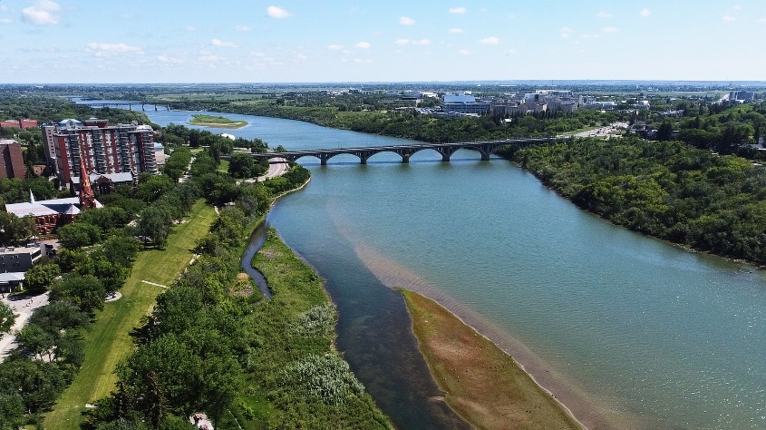
Figure 2 A picture is treated in the same way as diagram. Paragraph formatting was used to ensure the picture and caption appear together.

Subheading in a heading section
Subheadings are recommended to provide clarity of ideas. The subheading should be in bolded 12-point Times New Roman font. The first letter of the subheading should be in upper case and the remaining words should be lower case unless the word requires upper case. Subheadings are numbered with a period separating the section number and the subheading number (e.g., 2.1 and 2.2 are subheadings in section 2). The subheading title is separated from the subheading number by a tab space 1 cm from the left margin. The body of text in the subheading section is aligned and formatted identical to other sections. A single line is used to separate a sub-headed section from other sub-headed sections and other text in the same heading section.

Sub-subheading in a sub-headed section
In case a sub-subheading is required, the same principles apply. The sub-subheading title is to be in underlined (i.e., non-bolded) 12-point Times New Roman font.

References
References in the text can be made to literature listed in the reference section, located at the end of the paper, by numbering the literature with numbers in square brackets e.g., [1]. The references are incremented in sequence of appearance in the text. Repeated references to the
same literature can be made using the same reference number [1]. In this case, the reference number will be incremented on the next new literature cited.
The format for references should be: name of authors (authors are separated by commas), “Title of paper within quote marks with the first letter upper case and the rest lower case unless the word requires upper case”, Journal name in italics, Vol. number, Issue number, year and pages [1]. In the case of conference proceedings, underline the conference name [2].
For formulae, equations are numbered in their order of appearance in round brackets and are referred in the text if necessary.
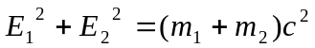 (1)

Wide diagrams or tables
If a diagram or table is too wide, it is recommended that the section of the paper be formatted in landscape orientation. The caption for the diagram should appear below the respective diagram and that for the table should appear above the respective table. Care should be taken to ensure that only the diagram or table, and caption, which needs to be displayed in landscape print, is formatted as such.

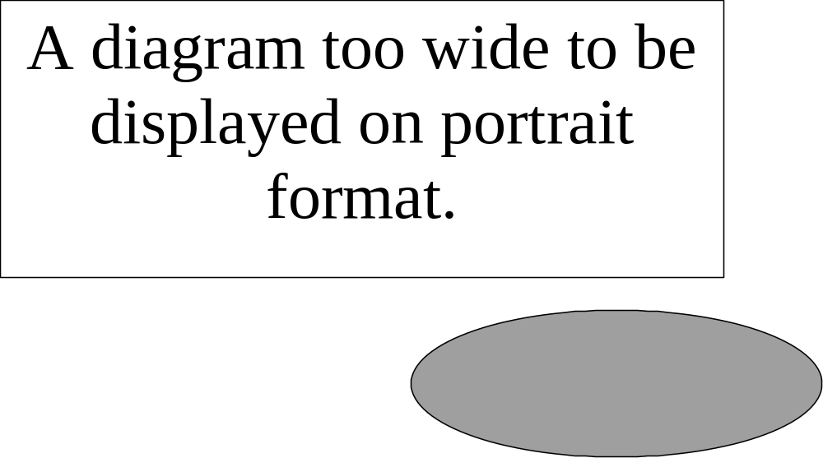

Figure 3 Example of a diagram too wide for portrait orientation

Conclusion
We have developed a format for the full papers submitted to the CNS ICNF 2026. We hope that the authors find this template useful and the guide easy to use. If there are any problems or questions regarding this template, please contact us at pirom@mcmaster.ca. We wish you every success in the preparation of your full paper.

References
[1] R.H. Brown, “A method to make reference to literature”, Journal of Citation, Vol. 11, No. 2, 1988, pp. 195-204.
[2] J.D. Irish and S.R. Douglas, “Validation of WIMS-IST”, Proceedings of the 23rd Annual Conference of the Canadian Nuclear Society, Toronto, Ontario, Canada, 2002 June 2-5.

